VACN Fall Meeting
Sunday, October 28, 2018
6:00 pm
JW Marriott – Washington, DC
Present: Shanna Akers (Liberty), Melody Cash (EMU), Melody Eaton, (JMU), Dorrie Fontaine (UVA), Jean Giddens (VCU), Pamela Giles (Averett), Pamela Jeffries (GW), Jeanne Matthews (Marymount), Chris-Tenna Perkins (Bon Secours), Rhoda M urray (Jefferson College of Health Sciences), Julie Sanford (JMU), Jessica Sharp (Bluefield), Yosley Cruz-Fernandez (Bluefield), Brbara Sorbello (Bon Secours), Kimberly Little (Longwood), Joe Tacy (JMU), Debra Barksdale (VCU), Cindy Rubenstein (Randolph-Macon)

Guest: Patricia Kraft (Regent)

Meeting Facilitator: Jean Giddens Meeting Recorder: Pamela Giles

Agenda Item | Report/Discussion | Decisions/Actions
 | - Meeting called to order at 6:35 | n/a
Welcome and Introductions  Jean Giddens |  | n/a
Review of Mailing List | - Members to make any corrections and to indicate their attendance at the meeting | n/a
Review of agenda | - No additions to the agenda were suggested | n/a
Meeting Minutes  Pamela Giles | - Reviewed meeting minutes from April 13, 2018 at ODU, Webb University Center. | - Approved by consensus.
VACN Bylaws Revision Update  Pamela Giles | - Proposed changes were discussed at our April 13 meeting and all agreed to conduct the vote online.  - The voting survey opened on August 31 and ended September 14.  - 14 votes were cast which resulted in unanimous approval of revised ByLaws | n/a
Treasurer’s Report  Kathleen LaSala | - Treasurer’s Report was included in the packet and reviewed.  - There are still some schools that need to pay the VACN dues.  - Questions re: options for paying dues | - Kathleen to send out an email re: options for paying dues (credit card, etc.)  - Approved by consensus (see attached)

VACN Website  Jean Giddens | - Jean reviewed the process by which the  website was created.  - Screenshots were printed and shared for members to review.  - Discussion re: what types of news/updates/information should be on the website.  - AACN would like to do this for other states, so we are the test pilot.  - Jean and Pam are meeting with the AACN website manager on 10/29  - Suggested links:  - There is interest in having a discussion board/listserve that is exclusive to VACN members.  - AACN has a “State Snapshot” on their website that is difficult to find; suggested to have a link to the Virginia Snapshot on the VACN site  - Congress.gov – follow the progress of bills  - Virginia General Assembly link – follow the progress of bills.  - Members log in with their AACN login  - The VACN Secretary will be the point person to update the website; updates will be solicited every 6 weeks.  - Three VACN logo options were reviewed | - No decision was made re: the logo  - Jean will review the website and Pam will send out the finalized link to all the members.
Virginia BON NCLEX pass rates and clinical hours  Julie Siemers | - Julie was not at the meeting | - Put on agenda for April meeting
Paying for grad clinical sites  Pamela Jeffries | - Clinical sites are asking some schools to pay for NP clinical placements; it’s a national trend  - JMU pays for FNP students – (25 students/year) – a few hundred dollars  - JMU charges a flat fee that covers sim, HESI, tech, clinical placement, etc.  - Marymount – was asked to pay $500/student/semester  - GW - $2900/student/semester  - $500/semester/nursing student – Liberty  - $2500/semester/med student – Liberty  - Some states are passing laws that NP preceptors who don’t charge receive a tax benefit  - Jeanne Matthews – believes more advanced NP students shouldn’t have to pay  - Duke pays for clinical placements  - Clinical sites are even beginning to ask payment for BSN clinicals  - Suggested we do a research project on the topic for the state of VA and present a white paper on the topic. | - n/a
Other Topics:  Work with the VBON re: faculty:student ratio for community health clinical hours  Jean Giddens  % of simulation hours per clinical course  Patricia Kraft | - Current VBON regs require direct supervision for community health clinical hours  - There is interest in initiating a conversation with the VBON to reconsider the faculty: student ratios for community health clinical experiences.  - There is also concern that VA is behind other states re: the % of simulation hours/clinical course, especially in light of NCSBN report. | - Jean will invite the VBON to our Spring meeting to discuss these concerns as our major focus for the meeting.  - Jean will lead preparations for that meeting.
VACN Elections for Spring, 2019 Barbara Sorbello | - Voting in a new President and a new Treasurer | n/a
VACN Meeting Spring, 2019  Shanna Akers | - Friday, April 5, 2019 @ Liberty University | - Possibility of a speaker to talk on competency-based education  - See above re: VBON speaker
School Updates | - Handouts were distributed | n/a
Adjournment | - Meeting was adjourned at 7:50 | n/a

Respectfully submitted,

Pamela Giles
VACN Treasurer’s Report
Submitted by Kathy LaSala

 | Checking | CD # 1 | CD #2
Starting Balance  9-1-2017 | $ 9816.61 | $ 5,778.10 | $ 675.06
Expense  J.W. Marriott Fall Dinner | - 2,887.50
Deposits  Annual dues  15 x $200 | + 3,000.00
Balance  10-28-2017 | $ 9,929.11 | $ 5,778.10 | $ 675.06
Deposit annual dues  6 x $200 | + $1,200
Balance  4-10-2018 | $11,129.11 | $5,778.10 | $675.83
Deposit of dues | +200.00
Expense – NurseTim Speaker | - 1,507.88
Expense – Marriott Deposit  (7/31/2018) | -1,500.00
Balance 7/31/18 | +8,121.00
Dues deposit  13x $200  1x $150  10/22/2018 | +2,950
Expense-  Marriot remaining balance  10/2018 | -1,250
Balance  10/22/2018 | $ 9,821.00 | $5,792.59 | $ 676.33
Dues (8 remaining outstanding  $1,800 more) | +1,600
Potential balance | $11,421  Potential

VACN LOGO OPTIONS

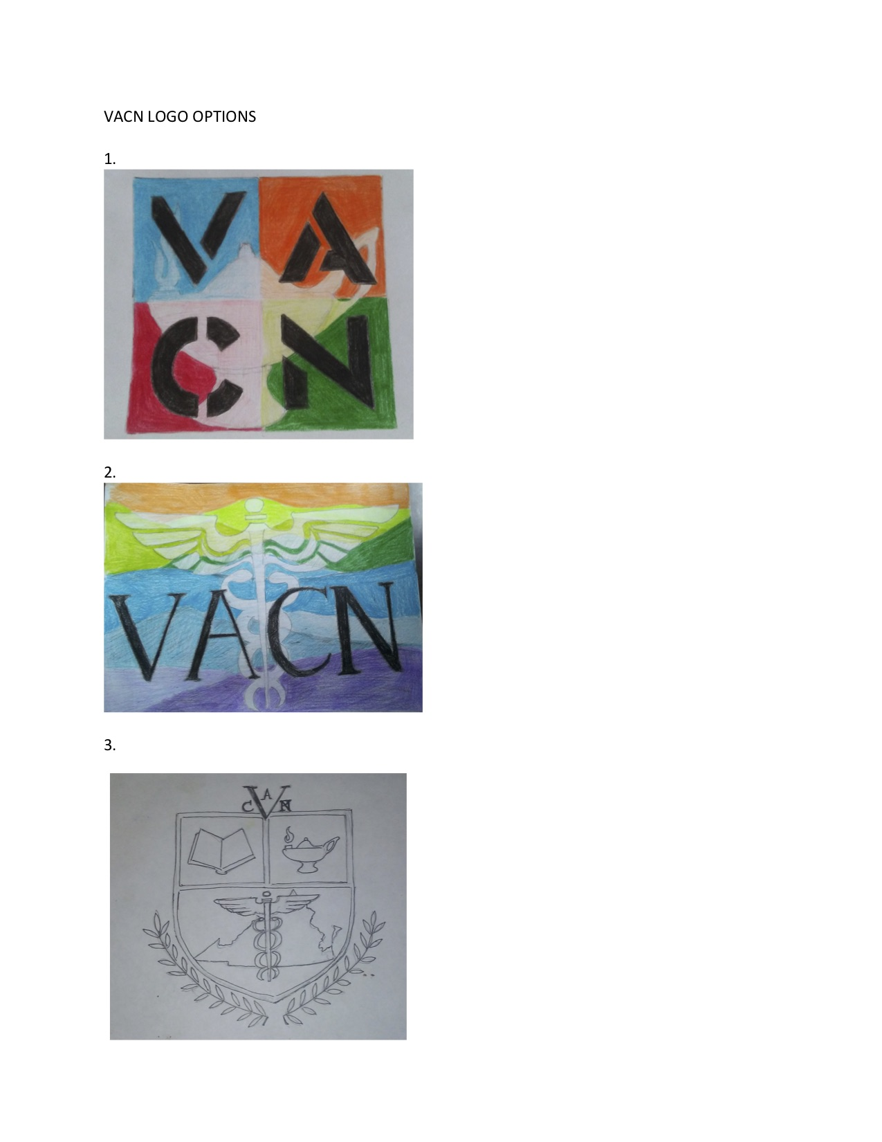
SCHOOL REPORTS/UPDATES

Virginia Association of Colleges of Nursing (VACN) School Updates
Annual Fall Dinner Meeting
Sunday, October 28, 2018

Averett University School of Nursing
Submitted by Dr. Pamela Giles, Dean

- In February, 2018 the VBON granted full approval of our BSN degree program
- Our Spring, 2018 graduates achieved a 100% NCLEX pass rate
- Our CCNE mid-term report is due December, 2018
- We welcomed two new faculty to the School of Nursing this Fall – Dr. Ryan Mallo and Prof. Kimberly Lott
- A newly-designed BSN curriculum received final faculty approval in August, and will launch in fall, 2019. This brings the BSN program in line with the overall degree requirements at Averett and other schools, incorporates required and desired content, and results in a time and cost savings for students and their families.
- On October 3-4 nursing faculty participated in the 2018 Southern Virginia Career ChoICE Youth Expo at the Olde Dominion Agricultural Complex. There were several thousand elementary and middle school students who participated, and we had a great response at our nursing booth.

George Mason University School of Nursing
Submitted by Dr. Cheryl Oetjen, Assistant Dean & Interim Director

The SON at GMU has been busy with the many changes in leadership within the College of Health & Human Services.

Dean, CHHS: Dr. Germain Louis Buck
Interim Director, School of Nursing: Dr. Cheryl Oetjen
Dr. Carol Urban has moved into the position of Associate Dean of Practice & Strategic Initiatives

PhD Program: Dr. Kevin Mallinson
UG Program: Dr. Charlene Douglas
MSN/DNP Programs: Dr. Cheryl Oetjen

Overall, the plan for the CHHS and SON is a move towards public health. The newly updated strategic plan reflects this focus.

The School of Nursing leads the college in grant funding. Current grants include:
ANEW: Allows for stipends for our primary care nurse practitioners and curriculum changes to include a focus on population health. The development of a preceptor portal and implementation of telehealth into the curriculum are in development. The ANEW grant will partner with the MAT grant to prepare our practitioners for the MAT waiver.

NEPQR: Allows for stipends for our pre-licensure students. The focus in on public health nursing. The student spend time in the MAP clinics learning the skills needed to be care coordinators.

SBIRT: The State SBIRT grant continues as this screening is implemented across Virginia.

MAT: This new SAMHSA grant will provide training for our primary care nurse practitioner students to attain the knowledge, skills, and attitudes necessary to prescribe MAT. The waiver will be attained after licensure. The grant is partnering with our ANEW faculty and students.

Integrative Care: Through this grant, an integrative care model has been implemented at Loudoun Free Clinic. This provides a clinical site for some of our DNP students to implement their DNP project.

The SON continues to offer experiential learning through our practicum courses. The many opportunities include:

The Mason & Partners (MAP) Clinics: There are now 8 operational sites for these nurse-led clinics. The sites range from primary care to population-specific sites. Our students rotate through these sites which has been an interprofessional endeavor that includes social work, health information and technology, nutrition, and administration students. Our community partners are also providing services at the clinics.

Inova Evidence-Based Projects: The DNP students have immersion experiences within the hospital system to assist the units with the planning and implementation of evidence-based projects. This has improved their ability to develop their own DNP Projects.

Outreach: GMU continues to offer a Return-to-Practice program for nurses re-entering the nursing profession. The program runs over a 4- to 6-week period with both didactic and clinical sessions.

This report provides a highlight of some of the happenings in the SON. The school also is in the process of developing their self-study as well as updating the curriculum to the undergraduate program.

University of Virginia School of Nursing
Submitted by Dr. Dorrie Fontaine, Dean, and
Dr. Christine Kennedy, Associate Dean for Academic Programs

Class of 2018
 | Degrees Conferred in Spring 2018
BSN | 118
MSN | 103
Post-Master’s Certificates | 8
DNP | 21
PhD | 6
Total | 256

As of October 17, 2018, 95% BSN graduates have secured employment (81 out of 85).

Undergraduate Education
- Curriculum: following a review of the new BSN curriculum, the BSN faculty proposed and passed curricular enhancements.
- RN-to-BSN: the faculty decided to transition the course modality from face-to-face to hybrid beginning in fall of 2019.
- Simulation: the staff of the SON’s Mary Morton Parsons Clinical Simulation and Learning Center have worked to significantly enhance and increase the number of simulations, collaborating with faculty members to improve students’ preparation, competence, and confidence in the clinical setting.
- Community clinic: following the departure of the long-time community agency sponsor who maintained a clinic at two community housing sites in Charlottesville, SON leadership worked with community leaders and organizations to continue this clinic with a SON faculty nurse.

Graduate Education
- Grant from the UVA Strategic Investment Fund: the School continues to implement activities under a $2.2 million grant (awarded 2017-18) under the leadership of Associate Dean Kennedy. The award is supporting specific initiatives in the neonatal and pediatric acute care NP programs to amplify research to create clinical scholars, offer scholarships to highly competitive students, develop faculty depth (across the advanced practice programs) in digital learning for the 21st century, and create innovative collaborative teams of nursing scientists, clinicians and teaching faculty.
- Grant from the Bedford Falls Foundation: two additional gifts for $10 million total were awarded in 2018 to support student scholarship packages as well as the CNL program.

Longwood University Department of Nursing
Submitted by Dr. Kimberly Little, Chair

Longwood University experienced a very successful and prosperous academic year for 2017-2018, and continues on with exciting additions for 2018-2019. On November 6, 2017, the Commission on Collegiate Nursing Education (CCNE) reaffirmed the accreditation of the BSN program for Longwood University for a period of 10 years.
The Longwood Nursing program is pleased to report a 3-year, 100% NCLEX pass rate for all graduates of our pre-licensure BSN program. As of date, Longwood University is the only BSN program in the Commonwealth of Virginia to bestow this honor. As one of two programs in the Commonwealth of Virginia to admit students directly into Nursing as a freshman, our admission standards continue to be strong and met well by the candidates for admission.

Applications for our BSN program remain strong as well, with an annual 550 applications being received, and 350 reviewed for 65 freshman slots. The majority of our students are residents in the Commonwealth of Virginia, with less than 5% being considered out-of-state residents. Faculty feel this strong admissions process lends to success during and at the end of the program.

Dr. Kim Little was hired as the Program Chair and Director of the Program July 1st of 2018. She comes to the program with 18 years of experience in Nursing Education. She holds a PhD in Nursing Education from UNLV, and has recently completed her Certification as a Women’s Health Nurse Practitioner, from Vanderbilt University. Her most recent academic appointment was serving as the Program Chair for the MSN program at Liberty University. She recently authored a textbook with Elsevier on the Patient Care Technician, and her research focus includes nutrition in the developing country of Guatemala, and student engagement in online education.

Longwood Nursing faculty are striving towards achieving terminal degrees. Dr. Pamela Crowder recently completed her Doctor of Nursing Practice from George Mason University. Four additional faculty are currently enrolled in terminal degree programs.
Over the spring and summer of 2018, the Nursing department raised funds to purchase the Beam Pro Telepresence robot for the simulation center. This addition will allow for students to use telehealth equipment to interact with other disciplines during simulated clinical experiences. With the support of our founding donor of the Longwood University Nursing Simulation Center, Dr. Gordon will be partnering with our students and faculty to focus on interdisciplinary collaboration and communication within the healthcare team.

Longwood is in the process of seeking applicants for a newly-created position of Clinical Coordinator. With Longwood being located in the rural area of Farmville, VA, students typically have a one-hour commute to clinical sites. Maintaining and growing these clinical sites is vital to insure our students have appropriate opportunities for learning. We are looking forward to hiring the ideal candidate to initiate and maintain these relationships with clinical affiliates.

Sentara College of Health Sciences
Submitted by Dr. Angela Taylor, Executive Director and Dean

In August, our first two MSN programs began, including a Master's Entry to Nursing Practice Program and a Clinical Nurse Leader Program. In addition, we were granted permission by Sentara Healthcare to pursue SACS accreditation; our targeted application date is July 2020, allowing for time to implement a Board of Trustees, complete college financial audits for three years, and complete college-wide assessments of general education competencies.

Randolph-Macon College Department of Nursing
Submitted by Dr. Cynthia Rubenstein, Chair and Professor

Randolph-Macon College approved a prelicensure BSN program in April 2018 which received initial VBON in August 2018. Marketing and recruitment are currently in process to admit 30 direct entry freshman nursing students in fall 2019. A ground-breaking is planned for March 2019 for the new nursing building, supported by private donors. Faculty hiring will begin in January 2019. Randolph-Macon College is a private, coeducational liberal arts and sciences college located 15 minutes north of Richmond in Ashland, Virginia.

Bon Secours Memorial College of Nursing
Submitted by Dr. Barbara Sorbello, Professor and Dean

- BSMCON Pre-licensure program has implemented the following curricular changes:
  - Transition to a 5 semester program effective Jan. 2019
  - Two higher level general education courses (6 credits) being taught at our College as a result of a new ABHES requirement
  - Course content refinement across the curriculum, merging of maternal-child and pediatrics courses and practica, into nursing care of families’ course and practicum.
  - New on-line electives developed for both pre and post-licensure students
  - Total credits now 120 (from 124)
  - Increase in enrollment to 80 twice per academic year (160 per academic year)
- BSMCON Post-licensure program has implemented curricular changes
  - Two higher level general education courses (6 credits) being taught at our College as a result of a new ABHES requirement
  - Course content refinement across the curriculum
  - New on-line electives developed for both pre and post-licensure students
  - Total credits now 120 (from 124)
  - Quality Matters Faculty Fellows program implemented to enhance quality of distance education
- Faculty
  - Assistant Dean for Scholarship of Discovery and Dissemination position filled
  - 5 new full time faculty hired to meet expanded enrollment needs
- Current campus expanded into neighboring space to provide two additional classrooms, simulation space, debriefing, student study spaces and faculty offices.
- Two additional academic counselors and simulation faculty and tech staff added.
- First time pass rate NCLEX-RN last academic year=99%
- Strategic Planning for the nursing programs for next five years underway.

Virginia Commonwealth University School of Nursing
Submitted by Dr. Jean Giddens, Dean and Professor

- Programs Offered
  - Undergraduate – Traditional, Accelerated, RN-BS
  - Master’s Program: FNP, PMHNP, AGACNP, AGPCNP, Nsg Adm Leadership.
  - DNP Program (3rd cohort started fall 2017)
  - PhD Program with 2 foci: Biobehavioral and Quality Safety

Program | Degrees Conferred in AY16-17
Baccalaureate | 221
Master’s | 72
PMC | 3
Doctoral | 15
Total | 311

- Curriculum Work
  - PhD curriculum revision approved
  - MS curriculum revision completed; undergoing approval
  - BS pre-licensure curriculum revision underway
  - Post graduate certificate in health care innovation; undergoing approval
- Student Success
  - NCLEX pass rate for 2017 =97.3%
  - NP Certification pass rates for 2016 range from 96% to 100%
- Total # of Faculty (as of Oct 2017) = 54
  - Non-tenure seeking =32
  - Tenure-seeking =5
  - Tenured =17
- Research FY2017
  - # proposals = 43
  - $ Awards = $1.24 million
- SON Initiatives
  - SON celebrating 125th Anniversary
  - New strategic plan – Beyond 125:
  - Search for new Director for Langston Center for Innovation in Quality and Safety
  - Expansion of Richmond Health and Wellness Program

Jefferson College of Health Sciences
Submitted by Dr. Rhoda Murray, Nursing Department Chair

- Planning is in process for the Jefferson/Radford merger. Summer 2019 is the estimated date for merger approval from SACSCOC.

- We received a fourth year of funding for Veteran’s Bachelor of Science in Nursing (VBSN) grant.

Eastern Mennonite University
Submitted by Dr. Melody Cash, Nursing Department Chair

- UG enrollment remains strong. We increased our clinical spots by 16 this year, including 8 in the accelerated second degree program.
- We have a new addition to our simulation lab and four new human patient simulators as well as a variety of other new equipment for student use.
- The RN-BS program continues to have fully online and hybrid (PA) options.
- We are exploring new tracks for our MSN in Leadership and Management program.
- The first cohort of DNP students began January 2019. The program is a consortium with Goshen College in Goshen, IN.

The George Washington University School of Nursing
Submitted by: Dr. Pamela Jeffries, Dean and Professor

The George Washington University School of Nursing is located in Ashburn, Virginia and is home to the Accelerated BSN and Veteran’s BSN Programs. There are approximately 400 students enrolled in these face to face programs (with almost 60 participating in the Veteran’s BSN Program) and another 75 students in the RN to BSN program which is entirely online.
Some updates regarding our space and students:
- The campus is located on 122 acres and is home to 7 buildings, 4 of which are academic.
- The campus is home to 4 simulation labs totaling 24,000 square feet
- GW Nursing opened a new state-of-the-art Student Success Center and Simulation Innovation & Learning Center in fall 2019.
- GW Nursing also launched the BSN Professional Wellbeing Initiative in fall 2018 to provide psychosocial, physical and educational support to students. A series of nine modules provides students with content on self-care skills to build resiliency, guidance on stress management, and effective study, communication and mindfulness practices. Students who attend the sessions and meet certain participatory requirements receive a notation from the dean on their transcript for completion of the program. The most popular sessions focus on managing and coping with stress, balancing multiple tasks, grit and resilience, and conflict resolution.
- Clinical partners include INOVA Loudoun Hospital, INOVA Fair Oaks, INOVA Alexandria, INOVA Fairfax, Virginia Hospital Center, Dominion Hospital, HCA Reston Hospital, GW Hospital, Med-Star Washington Hospital Center, Walter Reed National Military Medical Center, Veterans Administration Hospital, Loudoun Free Clinic, Prince William Free Clinic and others
- NCLEX pass rate of 93% from January-June 2018
- Last year, GW Nursing launched two new Master’s programs including the Psychiatric Mental Health Nurse Practitioner and the Acute Care Nurse Practitioner, along with a Post-Masters Certificate in Health Policy & Media Engagement.
- DNP and other graduate programs and certificates are online.
- GW Nursing will launch a PhD in Nursing program in fall 2019. Applications are currently being accepted and funding for studies will be provided to several students.

