SANE Training  Registration Form | Class Dates:  1st Session – May 28, 29 & 30 To receive your certificate and all 64.75 continuing  2nd Session – June 17, 18, 19, & 20 education contact hours. You must attend all of session 1 and 2.  Clinical Workshop – July 13 & 14  ----------------------------------------------------------------------------------------------------------------------------------------------------  Deadline to register: May 8, 2020 There is no cost for this training.

Class Location: Averett University, School of Nursing
Riverview Campus, Room 242 (2nd floor)
512 Bridge Street, Danville, VA 24541
Name: Click here to enter text. Title/Credential: Click here to enter text.
Address: Click here to enter text. City, State, Zip Click here to enter text.
Primary Phone: Click here to enter text. Email: Click here to enter text.

Affiliation/Employer: Click here to enter text.
Nursing License No: Click here to enter text.
How do you want the name on your certificate listed? Click here to enter text.
Emergency Contact Information:
Name: Click here to enter text. Phone: Click here to enter text.
Relationship Click here to enter text.

Let us know if you will need lodging accommodations, so we can reserve a block of rooms at the Comfort Inn in Danville, VA and participants will be able to receive the Averett discounted rate.
Will you need lodging? ☐ Yes ☐ No

For more information contact:
Debbie Pike - 434-791-7111
return completed form via email to: dpike@averett.edu

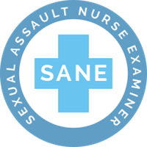
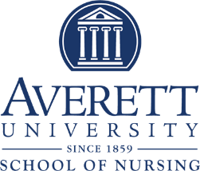

This training has been made possible, free of charge, by a grant obtained through Averett University. This project was supported by Grant No. 2018-WR-AX-0028 awarded by the Office on Violence Against Women, U.S. Department of Justice. The opinions, findings, conclusions, and recommendations expressed in this publication/program/exhibition are those of the author(s) and do not necessarily reflect the views of the Department of Justice, Office on Violence Against Woman.

